Date | 8/11/25
Team ID | NM2025TMID06649
Project Name | Medical Inventory Management
Maximum marks | 4 marks

Model Performance Testing:
S.No. | Parameter | Values | Screenshot
 | Model Summary | - | 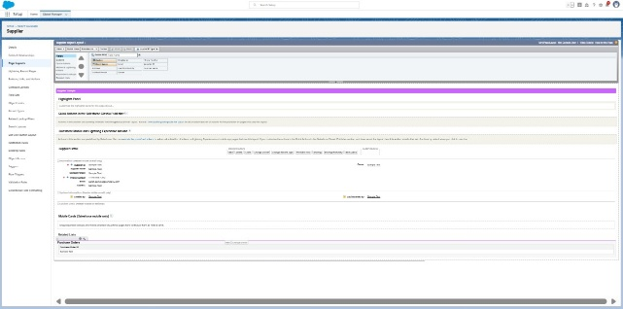
 | Accuracy | Training Accuracy – 90%  Validation Accuracy -90% | 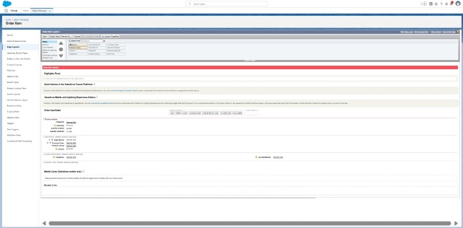
3. | Fine Tunning Result( if Done) | Validation Accuracy -90% | 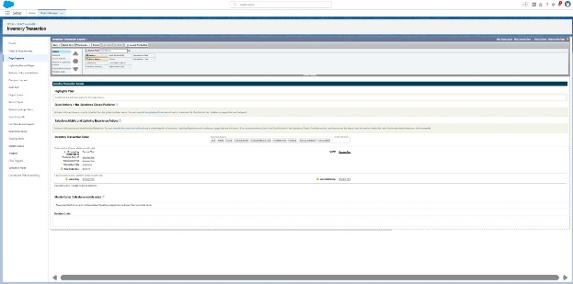

Test Scenarios & Results
Test Case ID | Scenario (What to test) | Test Steps (How to test) | Expected Result | Actual Result | Pass/Fail
FT-01 | Text Input Validation (e.g., topic, job title) | Enter valid and invalid text in input fields | Valid inputs accepted, errors for invalid inputs | 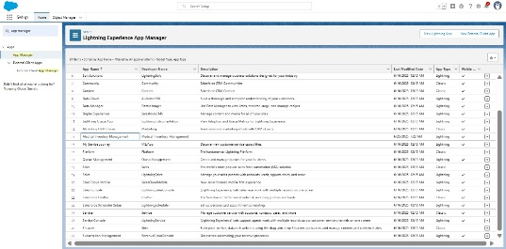
FT-02 | Number Input Validation (e.g., word count, size, rooms) | Enter numbers within and outside the valid range | Accepts valid values, shows error for out-of-range | 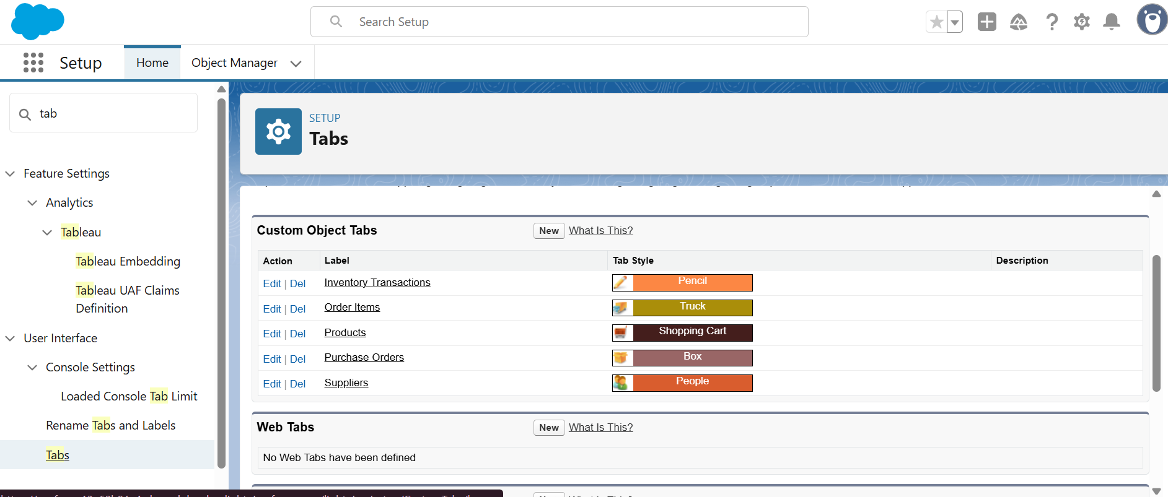
FT-03 | Content Generation (e.g., blog, resume, design idea) | Provide complete inputs and click "Generate" | Correct content is generated based on input | 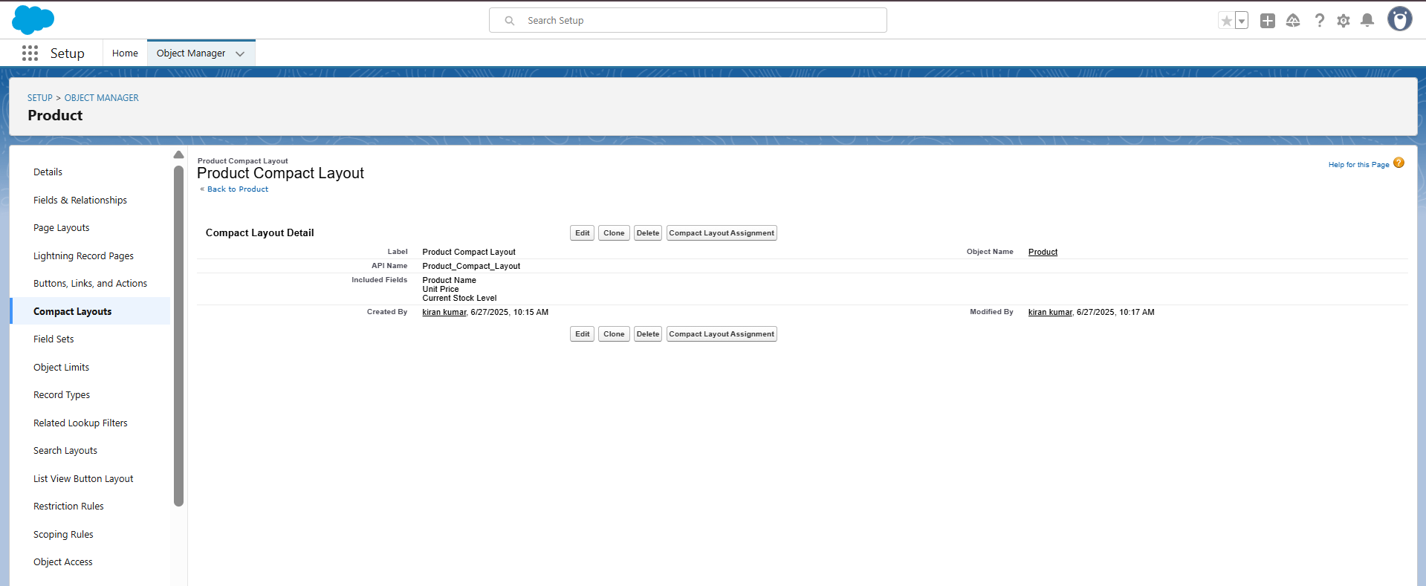
FT-04 | API Connection Check | Check if API key is correct and model responds | API responds successfully | 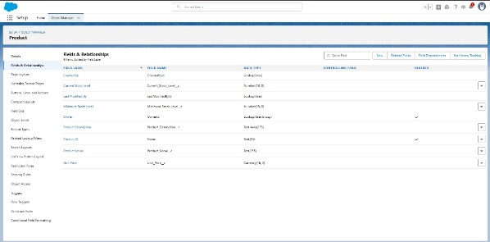
PT-01 | Response Time Test | Use a timer to check content generation time | Should be under 3 seconds | 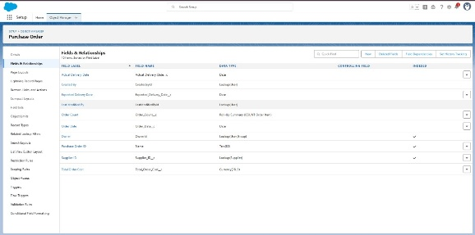
PT-02 | API Speed Test | Send multiple API calls at the same time | API should not slow down | 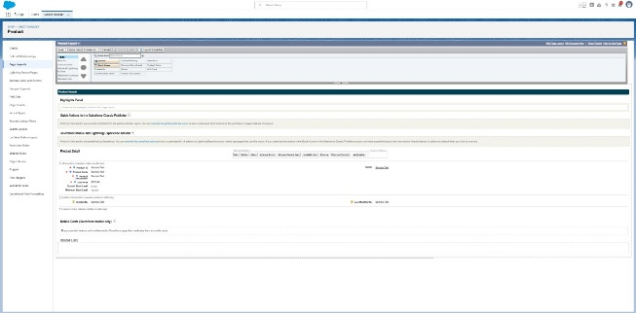
PT-03 | File Upload Load Test (e.g., PDFs) | Upload multiple PDFs and check processing | Should work smoothly without crashing | 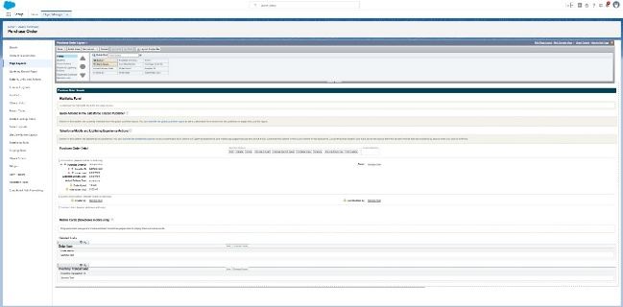

Model Performance Testing:
S.No. | Parameter | Values | Screenshot
 | Metrics | Regression Model:  MAE - , MSE - , RMSE - , R2 score -  Classification Model:  Confusion Matrix - , Accuray Score- & Classification Report - | 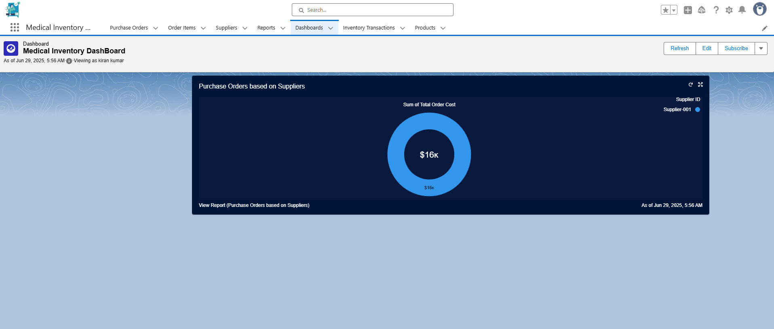
 | Tune the Model | Hyperparameter Tuning -  Validation Method - | 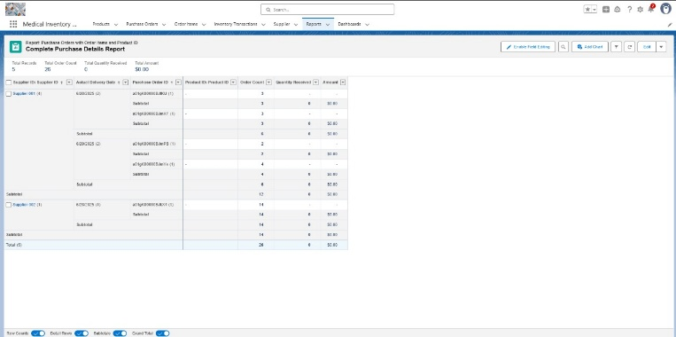

Model Performance Testing:

S.No. | Parameter | Screenshot / Values
 | Data Rendered | 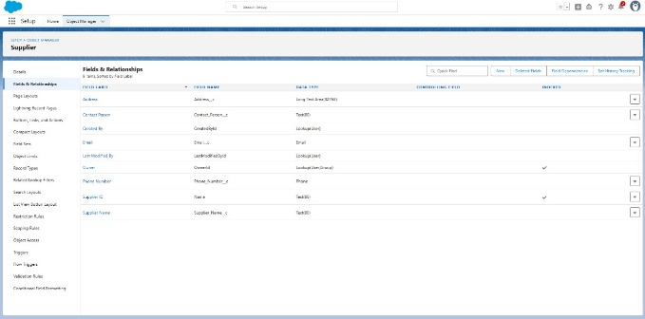
 | Data Preprocessing | 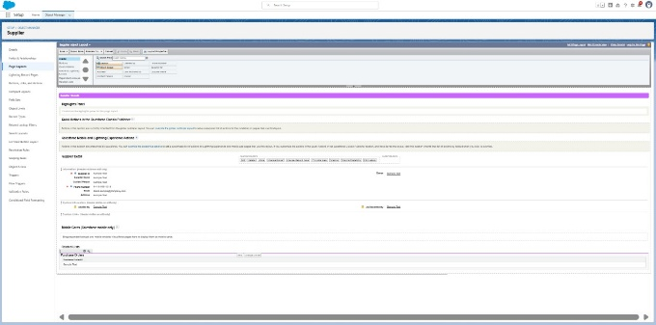
3. | Utilization of Data Filters | 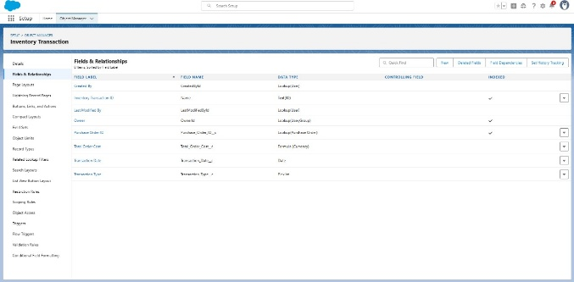
4. | DAX Queries Used | 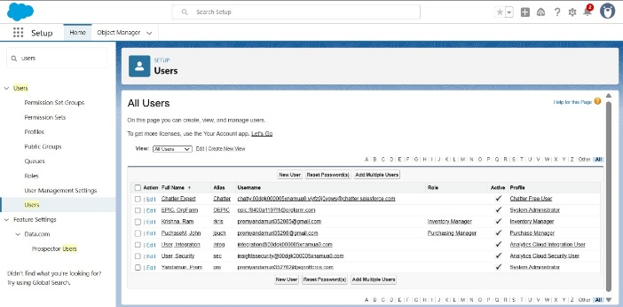
5. | Dashboard design | No of Visualizations / Graphs –  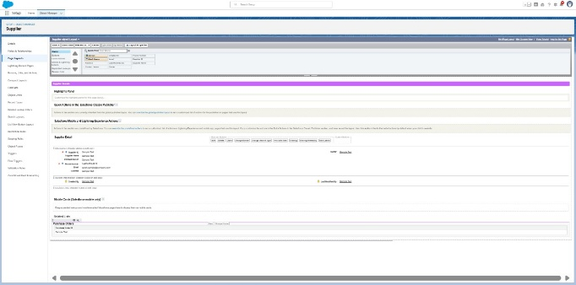
6 | Report Design | No of Visualizations / Graphs –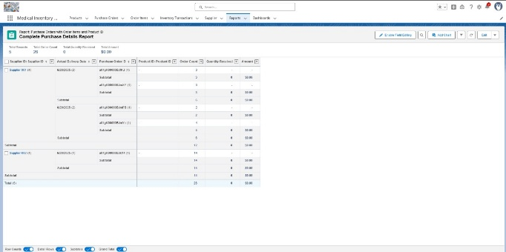

Model Performance Testing:
S.No. | Parameter | Values | Screenshot
 | Model Summary | Salesforce automation setup for Data management using Object, Fields and Reports.  Note : Import Records if data Match Correctly then Records will Created or Else it will Show Error | 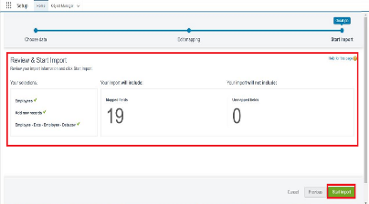
 | Accuracy | Training Accuracy - 98%  Validation Accuracy - 98% | - 
3. | Confidence Score (Only Yolo Projects) | Class Detected - If detecting Object and fields name if wrong and other activity  Confidence Score - If the model is 92% sure the object is correctly detected | 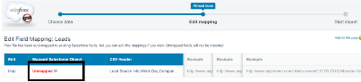  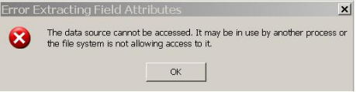

Model Performance Testing:.
S.No. | Parameter | Screenshot / Values
 | Data Rendered | 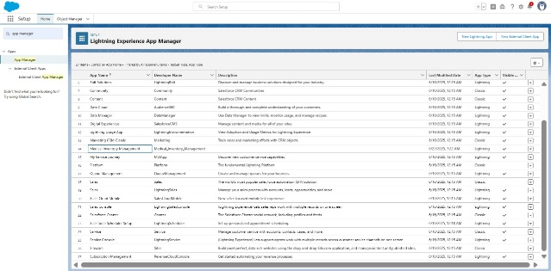
 | Data Preprocessing | 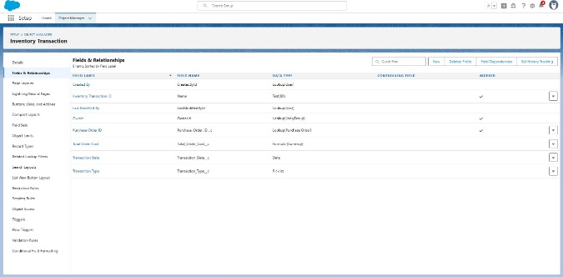
3. | Utilization of Filters | 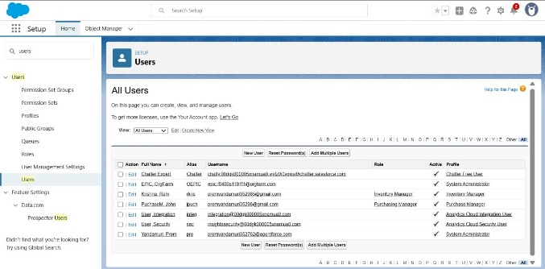
4. | Calculation fields Used | 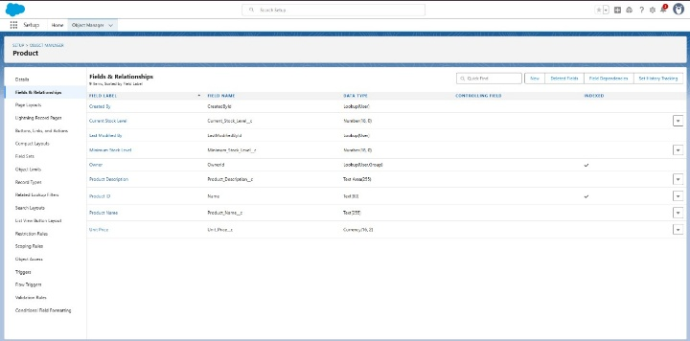
5. | Dashboard design | No of Visualizations / Graphs –
6 | Story Design | No of Visualizations / Graphs –  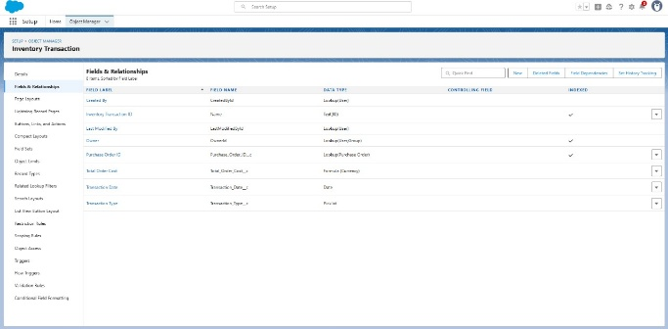

Project Overview
Project Name: Medical Inventory Management System
Platform: Salesforce

Project Description
The Medical Inventory Management System is an integrated Salesforce-based application designed to simplify and automate the management of medical supplies across healthcare institutions.
This project focuses on replacing traditional manual methods with a centralized, real-time, and intelligent solution that enhances accuracy, transparency, and efficiency in inventory operations.
The system caters to the specific needs of hospital administrators, pharmacists, and purchase managers by offering a complete workflow for managing stock, tracking expiries, handling purchase orders, and evaluating supplier performance.
By utilizing Salesforce’s automation and analytics capabilities, the platform ensures seamless coordination, reduced wastage, and improved compliance within hospital inventory operations.

Key Features
1. Supplier Management
Maintain comprehensive records of all suppliers, including essential details such as contact information, delivery history, and performance metrics.
This enables hospitals to monitor supplier reliability and build stronger procurement relationships.
2. Purchase Order Management
Easily create, modify, and track purchase orders within the system.
Automated workflows help streamline procurement activities, ensuring timely ordering, approval, and replenishment processes.
3. Product Catalog Management
Manage detailed product data, including:
- Product name and description
- Category and storage conditions
- Stock quantity and batch number
- Reorder levels and availability status
This organized catalog helps in quick reference and efficient inventory control.
4. Expiry Date Tracking
Monitor and manage expiry dates for all medicines and equipment.
Automated alerts notify users of upcoming expirations, reducing the risk of using outdated products and ensuring patient safety and regulatory compliance.
5. Transaction and Stock Movement History
Maintain a transparent log of all inventory transactions—stock received, issued, returned, or adjusted.
This provides complete traceability and accountability throughout the inventory lifecycle.
6. Reporting and Analytics
Generate insightful, data-driven reports on:
- Supplier performance and delivery timelines
- Purchase order frequency and spending trends
- Stock usage efficiency and wastage analysis
- Expiry tracking and compliance status
These analytics empower healthcare organizations to make informed decisions and continuously enhance their inventory management processes.
Test Cases:
Test Case ID | Test Scenario | Test Steps | Expected Result | Actual Result | Pass/Fail
TC-001 | Verify adding new medical inventory item | 1. Login to the system  2. Navigate to Inventory module  3. Add details and click save | The new item should be added successfully | The new item was added successfully | Pass
TC-002 | Verify low stock alert | 1. Login to the system  2. Navigate to Inventory module  3. Update stock to below minimum | System should generate low stock alert | System generated low stock alert | Pass
TC-003 | Verify deletion of expired medicines | 1. Login to the system  2. Navigate to Expired Medicines  3. Click delete | Expired medicines should be deleted from inventory | Expired medicines were deleted from inventory | Pass

Bug Tracking:
Bug ID | Bug Description | Steps to reproduce | Severity | Status | Additional feedback
BG-001 | Low stock alert not triggering  when stock reaches threshold level | 1. Login to the system  2. Update item to low stock level  3. Check for alert | Medium | Closed | Resolved after threshold fix
BG-002 | Expired medicine not removable  from inventory | 1. Login to the system  2. Navigate to Expired Medicines  3. Attempt to delete | High | In progress | Under investigation by dev team
BG-003 | Inventory page loading slowly | 1. Login to the system  2. Navigate to Inventory module  3. Observe loading time | Low | open | Performance optimization

